**Disparity estimation using block matching**

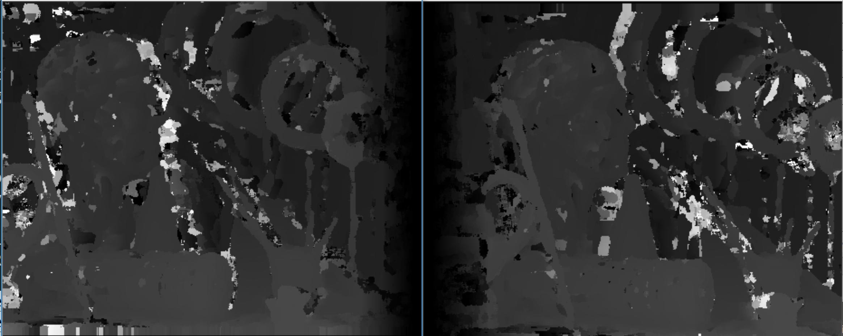

MSE= 1082, Block Size = 9 MSE= 1297, Block Size = 9

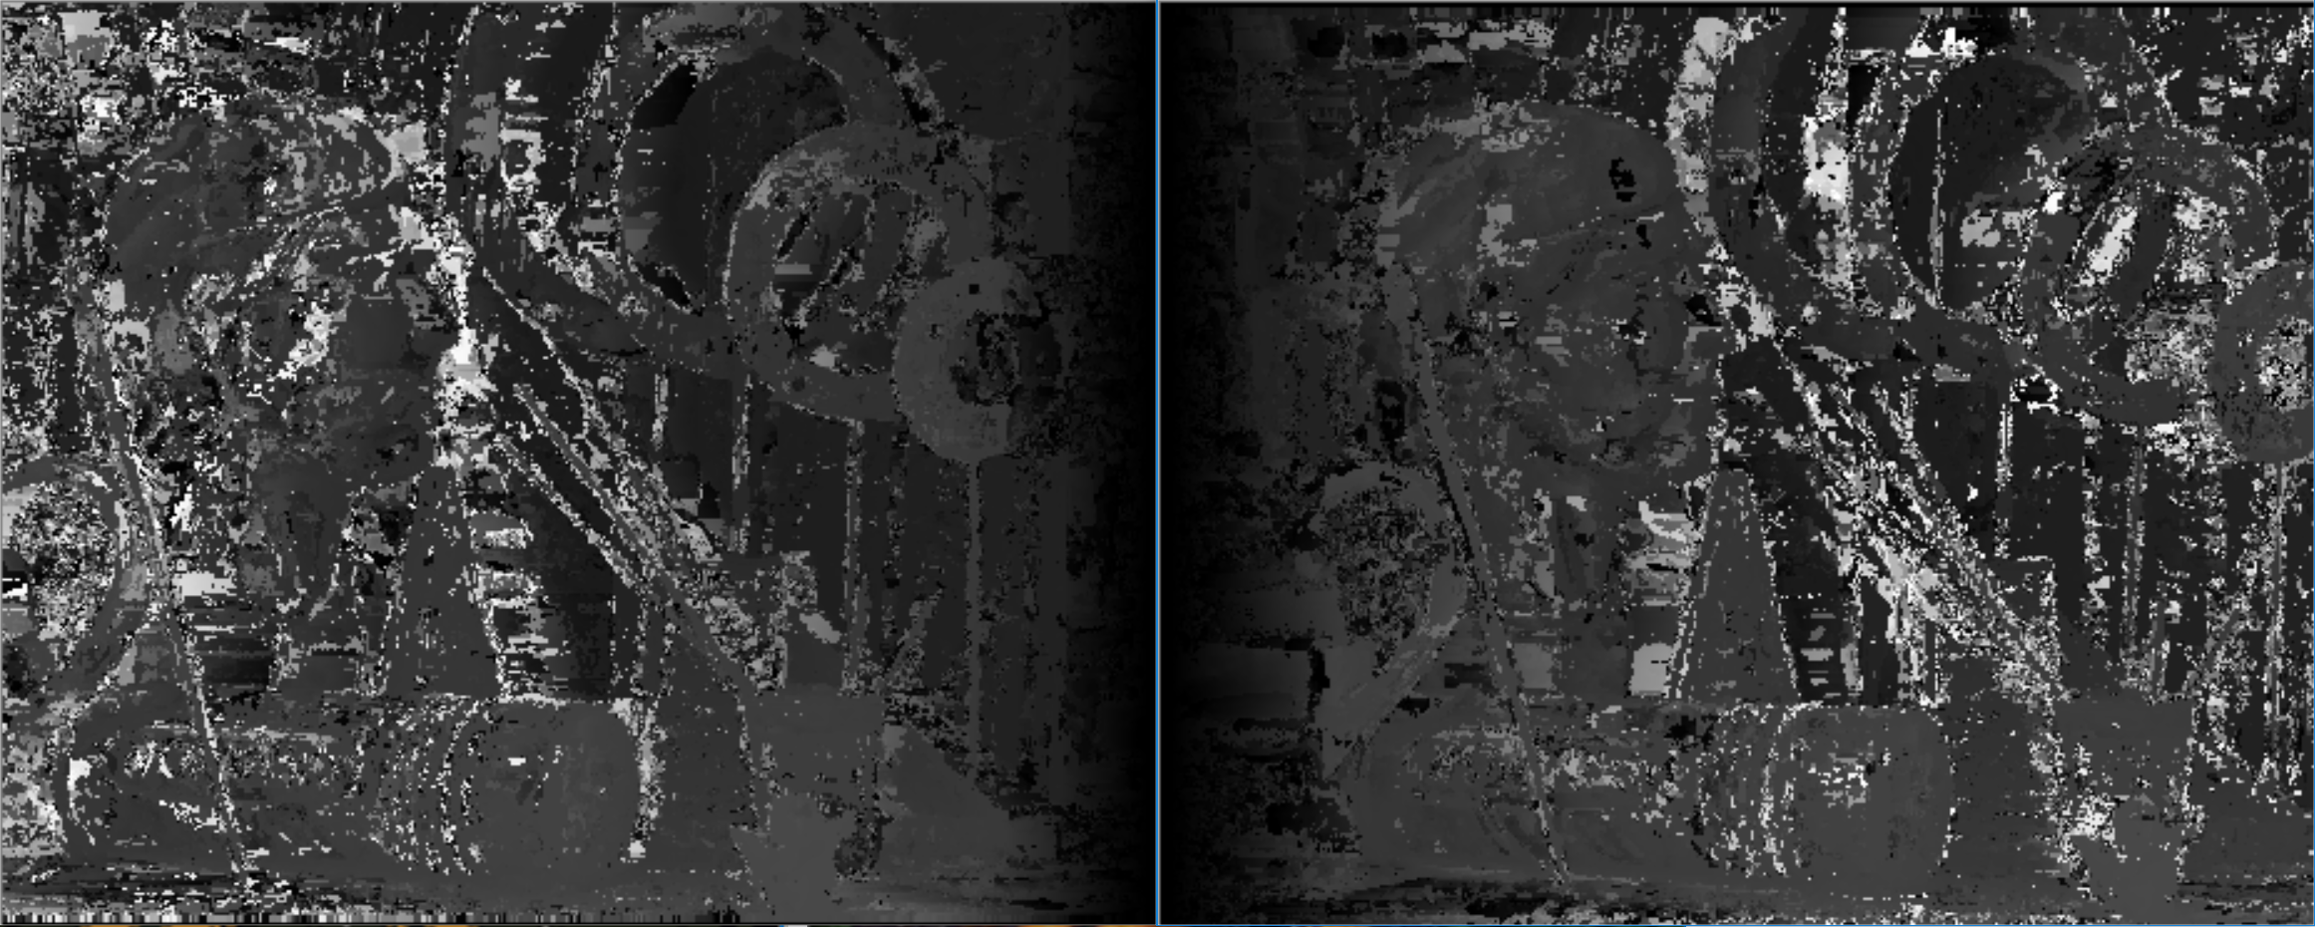

MSE= 2550, Block Size = 3 MSE= 2438, Block Size = 3

**Consistency check**

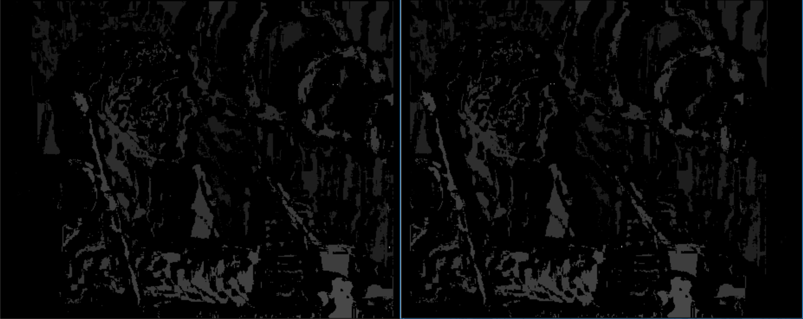

MSE= .78, Block Size = 9 MSE= 1, Block Size = 9

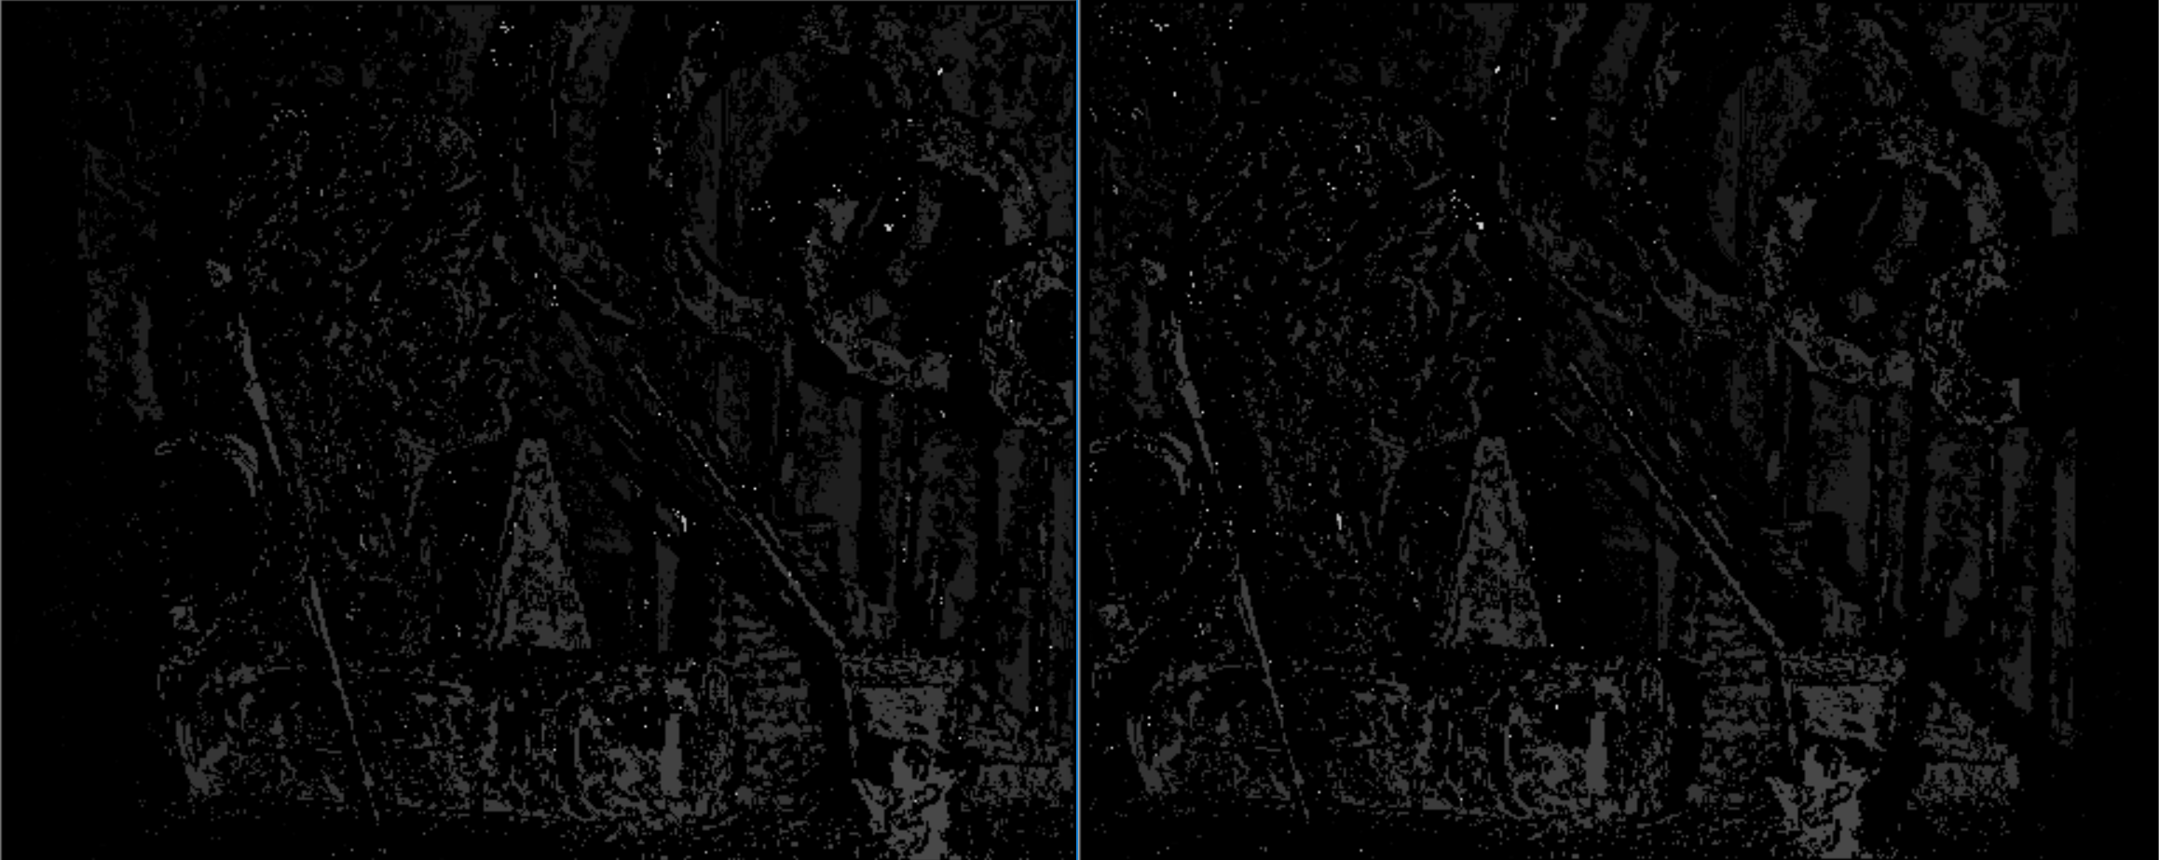

MSE= 1.18, Block Size = 3 MSE= 1.19, Block Size = 3

**Disparity estimation using Dynamic Programming**

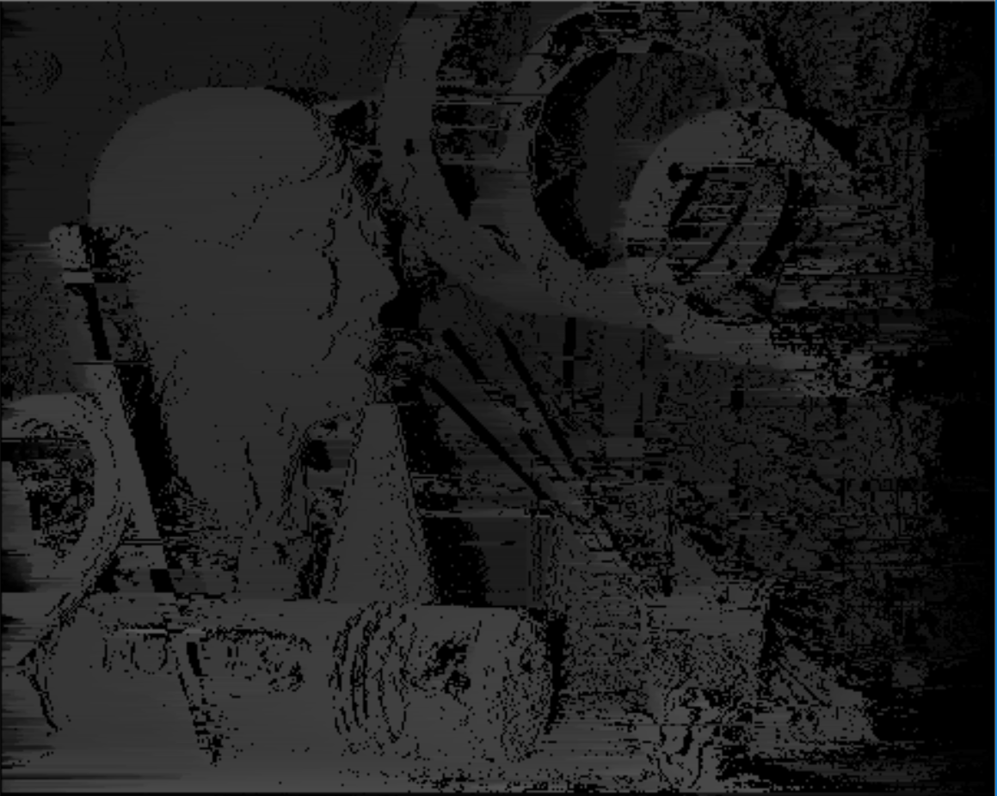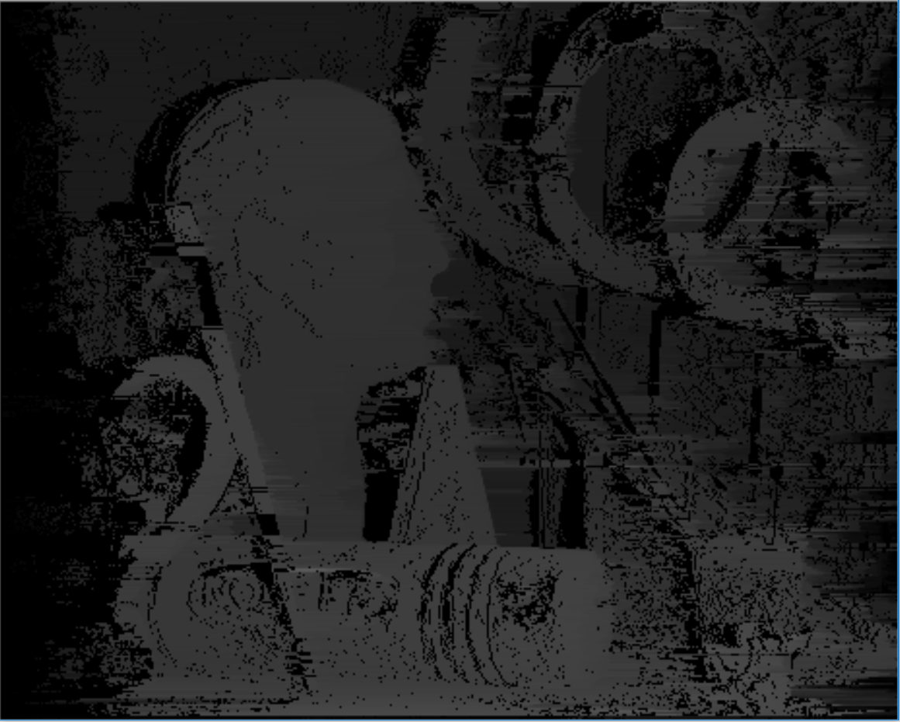

**View Synthesis**

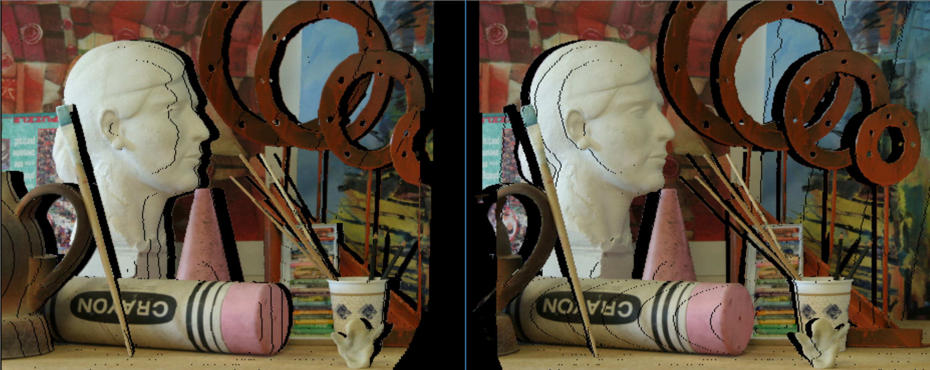

Images Shifted Disparity/2

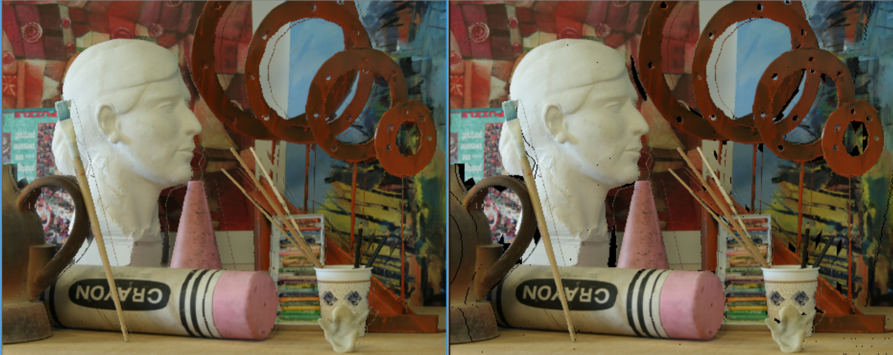

Synthesized and filled small holes Synthesized View

**Image Segmentation**



Window = 30 Window = 60

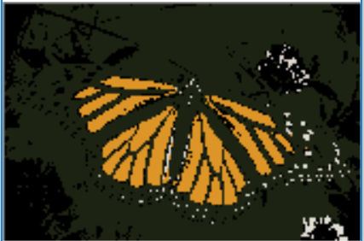 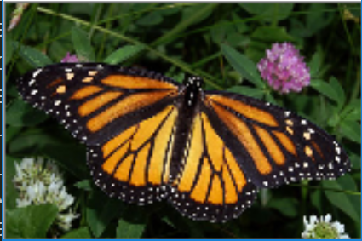

Window = 90 Image